Type the title of your paper here
X Y Xxx^{1,}*, X Y Z Xxxx¹, and Z Xxxx¹
¹Faculty of Earth Science, Universiti Malaysia Kelantan, 17600 Jeli, Malaysia
²Malaysian Agricultural Research and Development Institute, 43400 Serdang, Malaysia
*Corresponding author: xxx@xxx.edu.my
Abstract. Start your abstract here…
- Introduction
The first paragraph after a heading is not indented (Body text style) [1]. Example of citation in text [2, 3, 4].
Other paragraphs are indented (Body text Indented style).
Table 1. Summary of surface and groundwater quality in the research area.
Parameters | Minimum | Maximum | Mean | Standard Deviation | WHO (2011)
Temperature (°C) | 20 | 30.9 | 26.72 | 3.274 | 30 – 35
pH | 5.3 | 7.31 | 6.39 | 0.666 | 6.5 – 8

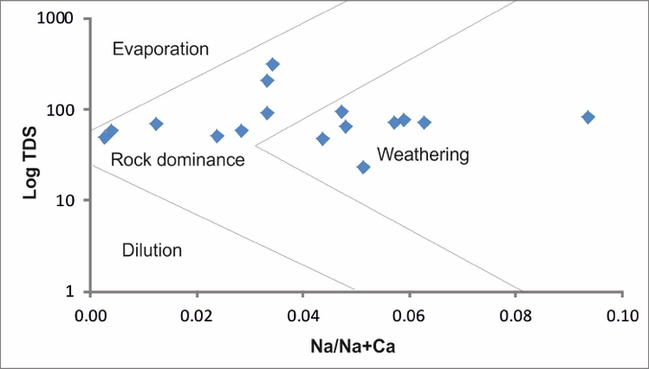
Figure 1. Cations plot in Gibbs (1970) diagram.
- Another section of your paper
The first paragraph after a heading is not indented (Body text style).
Other paragraphs are indented (Body text Indented style).

A subsection
Some text.
    - A subsubsection. The paragraph text follows on from the subsubsection heading but should not be in italic.
References
- Harun S, Uja N and Fikri A H 2015 Water Quality and Phytoplankton Distribution of the Lower Kinabatangan River Catchment, Sabah J. Trop. Res. Sust. Sci. 3 204–07.
- Richards L A 1954 Diagnosis and Improvement of Saline Alkali Soils: Agriculture, Handbook, US Department of Agriculture, Washington DC, 160.
- Another reference
- More references

