Type the title of your paper here
The list of authors should be indented 25 mm to match the abstract. The style for the names is initials then surname, with a comma after all but the last two names, which are separated by ‘and’. Initials should not have full stops. 11 points Times Bold.
Example: Muhamad Azahar Abas – M A Abas¹,

The title is set 17 point Times Bold, flush left, unjustified. Leave 28 mm of space above the title and 10 mm after the title.

X Y Surname/Last Name^{1,}*, X Y Z Xxxx¹, and Z Xxxx¹
¹Faculty of Earth Science, Universiti Malaysia Kelantan, 17600 Jeli, Malaysia
Times 10, Bold
Times 11, Not Bold
If the authors are at different addresses, numbered superscripts should be used after each surname to reference an author to his/her address. Ensure that any numbered superscripts used to link author names and addresses start at 1 and continue on to the number of affiliations. 11 points Times Not Bold.
²Malaysian Agricultural Research and Development Institute, 43400 Serdang, Malaysia
*Corresponding author: xxx@xxx.edu.my
Abstract. Start your abstract here…
Times 11. The text should be set to single line spacing. Paragraphs should be justified.
Times 10, Not Bold
- Introduction
The first paragraph after a heading is not indented (Body text style) [1]. Example of citation in text [2, 3, 4]. According to Abas et al. [3], some text
Other paragraphs are indented (Body text Indented style).
Table 1. Summary of surface and groundwater quality in the research area.
Parameters | Minimum  Times 11  - Table and number -bold  - caption- not bold. Should have a full stop at the end.  - position above table  - Tables should be centred unless they occupy the full width of the text.  - If it is difficult to make a table fit the page, use a smaller font.  Check all tables to follow format  Table heading: not bold  Table content-Times, 11, not bold unless nessasry | Maximum | Mean | Standard Deviation | WHO (2011)
Temperature (°C) | 20 | 30.9 | 26.72 | 3.274 | 30 – 35
pH | 5.3 | 7.31 | 6.39 | 0.666 | 6.5 – 8

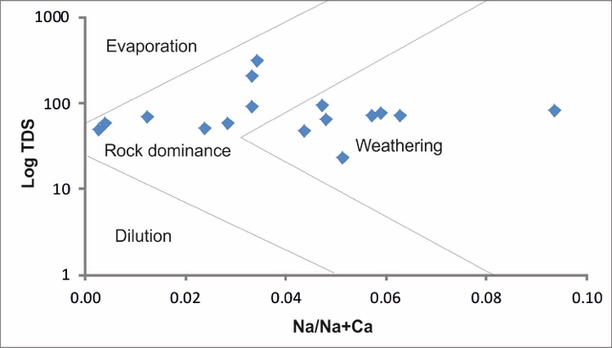
Times 11
- Table and number - bold
- caption- not bold. Should have a full stop at the end.
Check all figures to follow format
Figure 1. Cations plot in Gibbs diagram.
- Another section of your paper
The first paragraph after a heading is not indented (Body text style).
Other paragraphs are indented (Body text Indented style).

A subsection
Subsection, 11 point Times, Italic
The first paragraph after a heading is not indented (Body text style).
Other paragraphs are indented (Body text Indented style) .
Subsequent paragraphs should be indented by 5 mm.

    - A subsubsection. The paragraph text follows on from the subsubsection heading but should not be in italic.
11 point Times, Bold

There should be a 5 mm gap between the reference number (e.g., ‘[8]’) and the start of the reference text. Second and subsequent lines of individual references should be indented by 5 mm.
The authors should be in the form surname (with only the first letter capitalized) followed by the initials with no periods after the initials. Authors should be separated by a comma except for the last two which should be separated by ‘and’ with no comma preceding it.

The article title (if given) should be in lower case letters, except for an initial capital, and should follow the year (date).

The journal title is in italic and is abbreviated.
Both the initial and final page numbers should be given where possible. The final page number should be in the shortest possible form and separated from the initial page number by an en rule ‘– ‘, e.g. 4477–89, i.e. the numbers ‘44’ are not repeated.

Volume number in bold type.

References
- Harun S, Uja N and Fikri A H 2015 Water quality and phytoplankton distribution of the lower kinabatangan river catchment, Sabah J. Trop. Res. Sust. Sci. 3 204–07.
- Richards L A 1954 Diagnosis and improvement of saline alkali soils: agriculture, handbook, US Department of Agriculture, Washington DC.
- Mangoua M J, Gone D L, Kouassi K A, N’guettia K G, Douagui G A, Savane I and Biemi J 2015 Hydrogeochemical assessment of groundwater quality in the Baya watershed (Eastern of Côte d’Ivoire) African J. Agric. Res. 10 4477–89.

Books
References to a book should include:

Author(s): surname(s) and initial(s)
Year
Full title (in italics, the initial letter of each significant word should be upper case; note that if a word is hyphenated then both parts should have an initial capital letter; for example, Non-Classical Mechanics)
Town of publication
Publisher
Example: Whelan C T 2018 Atomic Structure (Bristol: IOP Publishing)

Detail of reference style, please visit https://publishingsupport.iopscience.iop.org/questions/style-guide-journal-articles/

