The effects of creep feed and commercial concentrates on growth performance of pre-weaning dorper lambs
Author Name One^{1*}, Author Name Two² and Author Name Three³
¹Complete affiliation with country name
²Complete affiliation with country name
³Complete affiliation with country name

ARTICLE HISTORY  Received : xx  Accepted : xx  Online : xx  KEYWORDS  Provide 4 to 7 keywords which can be used for indexing purposes.  ⌧* CORRESPONDING AUTHOR  Name of Corresponding Author  Affiliation of Corresponding Author  Email: | ABSTRACT  An abstract of 150 to 300 words that sketches the purpose of the study; basic procedures; main findings, its novelty; discussions and the principal conclusions, and any undefined abbreviations or references should not be included. It should be typed in Arial Narrow with 10 fonts and justified.  .

- INTRODUCTION
The introduction should state the purpose of the investigation and identify clearly the gap of knowledge that will be filled in the literature review study. The full paper must be a minimum of 5,000 words.
- MATERIALS AND METHODS
The materials and methods section should provide detailed information to permit repetition of the experimental work. It should include clear descriptions and explanations of sampling procedures, experimental design, and essential sample characteristics and descriptive statistics, hypothesis tested, exact references to literature describing the tests used in the manuscript, number of data involved in statistical tests, etc. All studies involving human or animal subjects must include an ethical approval statement, along with the corresponding approval or registration number.
2.1. Subtopic
Start here.
- RESULTS AND DISCUSSION
The Results section should describe the outcome of the study. Data should be presented as concisely as possible - if appropriately in the form of tables or figures, although very large tables should be avoided. The discussion should be an interpretation of the results and their significance with reference to work by other authors. Please note that the policy of the Journal with respect to units and symbols is that of SI symbols.
3.1 Tables
Tables and graphs should not be submitted as photographs and editable. Place explanatory matters in footnotes, not in the heading. Do not use internal horizontal and vertical rules. Tables should be called out in the text and should have a clear and rational structure and consecutive numerical order. All tables should be numbered (1, 2, 3, etc.). Give enough information in subtitles so that each table is understandable without reference to the text. For each table, please supply a table caption (title) explaining the components of the table. Identify any previously published material by giving the original source in the form of a reference at the end of the table caption. Tables should be with the captions placed above in limited numbers. Footnotes to tables should be indicated by superscript lower-case letters (or asterisks for significance values and other statistical data) and included beneath the table body. The caption of the table should be written in Arial Narrow of 9 font. For the content, Arial Narrow of 8 font.

Table 1: Chemical composition (mean ± standard error) of forage diet.
Parameters | Napier
Dry Matter (DM) | 19.37±0.5
Crude Protein (CP) (%) | 9.06±0.3
Ether Extract (EE) (%) | 2.05±0.3
Crude Fibre (CF) (%) | 35.7±0.3
Ash (%) | 5.86±0.2
3.2 Figures
Figures/ illustrations/line drawings as well as colour photographs should be in high quality artwork. Ensure that figures are clear, labelled, and of a size that can be reproduced legibly in the journal. Place all the figures and tables at the end of pages. The caption of figures should be written in Arial Narrow of 9 fonts. The manuscript should include a separate list of figures.

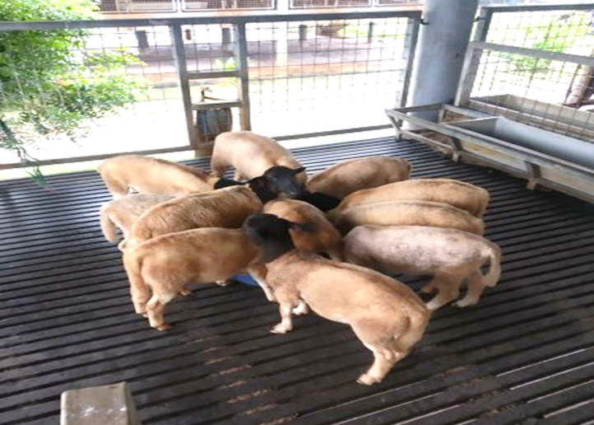

Figure 1: The concentrate was provided separately from the ewes
4. CONCLUSION
This section should highlight the major, firm discoveries, and state what the added value of the main finding is, without references from literature.
ACKNOWLEDGEMENT
Acknowledgements of people, grants, funds, etc. should be placed in a separate section before the reference list. The names and numbers of grant/grants and funding organizations should be written in full. Financial support affiliation of the study, if exists, must be mentioned in this section.
REFERENCES
All the references should be written in the following APA reference format. Examples as follows.

Abdelsattar, M. M., Vargas-Bello-Pérez, E., Zhuang, Y., Fu, Y., & Zhang, N. (2022). Impact of dietary supplementation of β-hydroxybutyric acid on performance, nutrient digestibility, organ development and serum stress indicators in early-weaned goat kids. Animal Nutrition, 9, 16–22. https://doi.org/10.1016/j.aninu.2021.11.003
Abebe, A., Gizaw, S., Bisrat, A., Goshme, S., Besufekad, S., Mekonen, T., Ababa, A. (2015). Growth Performance of Dorper and its F 1 Crossbreds at Debre- Birhan Agricultural Research Center. Developing Country Studies, 5(13), 90–99.
Agwa, H. M. M., Saleh, H. M., Abd El-Rhman, G. A., & Ayyat, M. S. (2016). Effect of Creep Feeding of Lambs and Plane of Nutrition of Ewes on the Productive Performance of Ewes During Suckling Period. Zagazig Journal of Agricultural Research, 43(2), 447462. https://doi.org/10.21608/zjar.2016.101531
Al-Sherwany, D.A.O. and Alkass, J.E. (2021). A Comparative Study on Growth, Carcass Traits and Body Composition of Awassi and Karadi Lambs Raised Under Two Levels of Feeding and Slaughtered at Different Weights: 1- Growth
Performance and Carcass Traits. Iraqi Journal of Agricultural Sciences, 52 (5), 1101–1108. https: //doi.org/10.36103/ijas.v52i5.1448.

